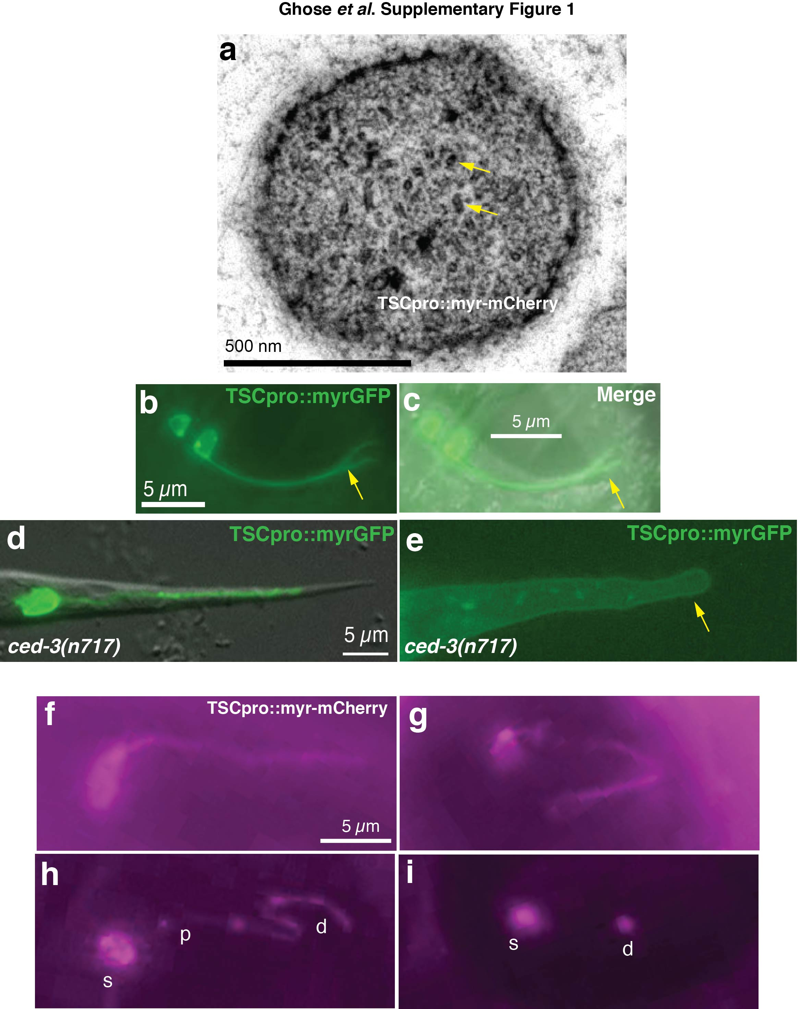

Supplementary Figure 1

The TSC extends a microtubule-laden process required for tail morphogenesis.
(a) Section of TSC distal process of 1.5-fold embryo. Arrows, microtubules. n=1. Scale bar, 500 nm (b, c) The TSC results from AFF-1-dependent fusion of two precursor cells. Forked tails with bifurcating processes (arrow) from unfused TSC precursors appear in aff-1(tm2214) mutants. n=2 biologically independent animals. (d, e) Normal and TSC-ablated L1 animals, respectively. n=5 biologically independent experiments. Arrow, misshapen tail tip in TSC-ablated animal. Scale bars: 5 μm. (f-i) TSCpro-myristoylated mCherry expressing embryos showing degeneration sequence similar to that of GFP version .n=2 biologically independent animals. s=soma, p=proximal process, d=distal process.

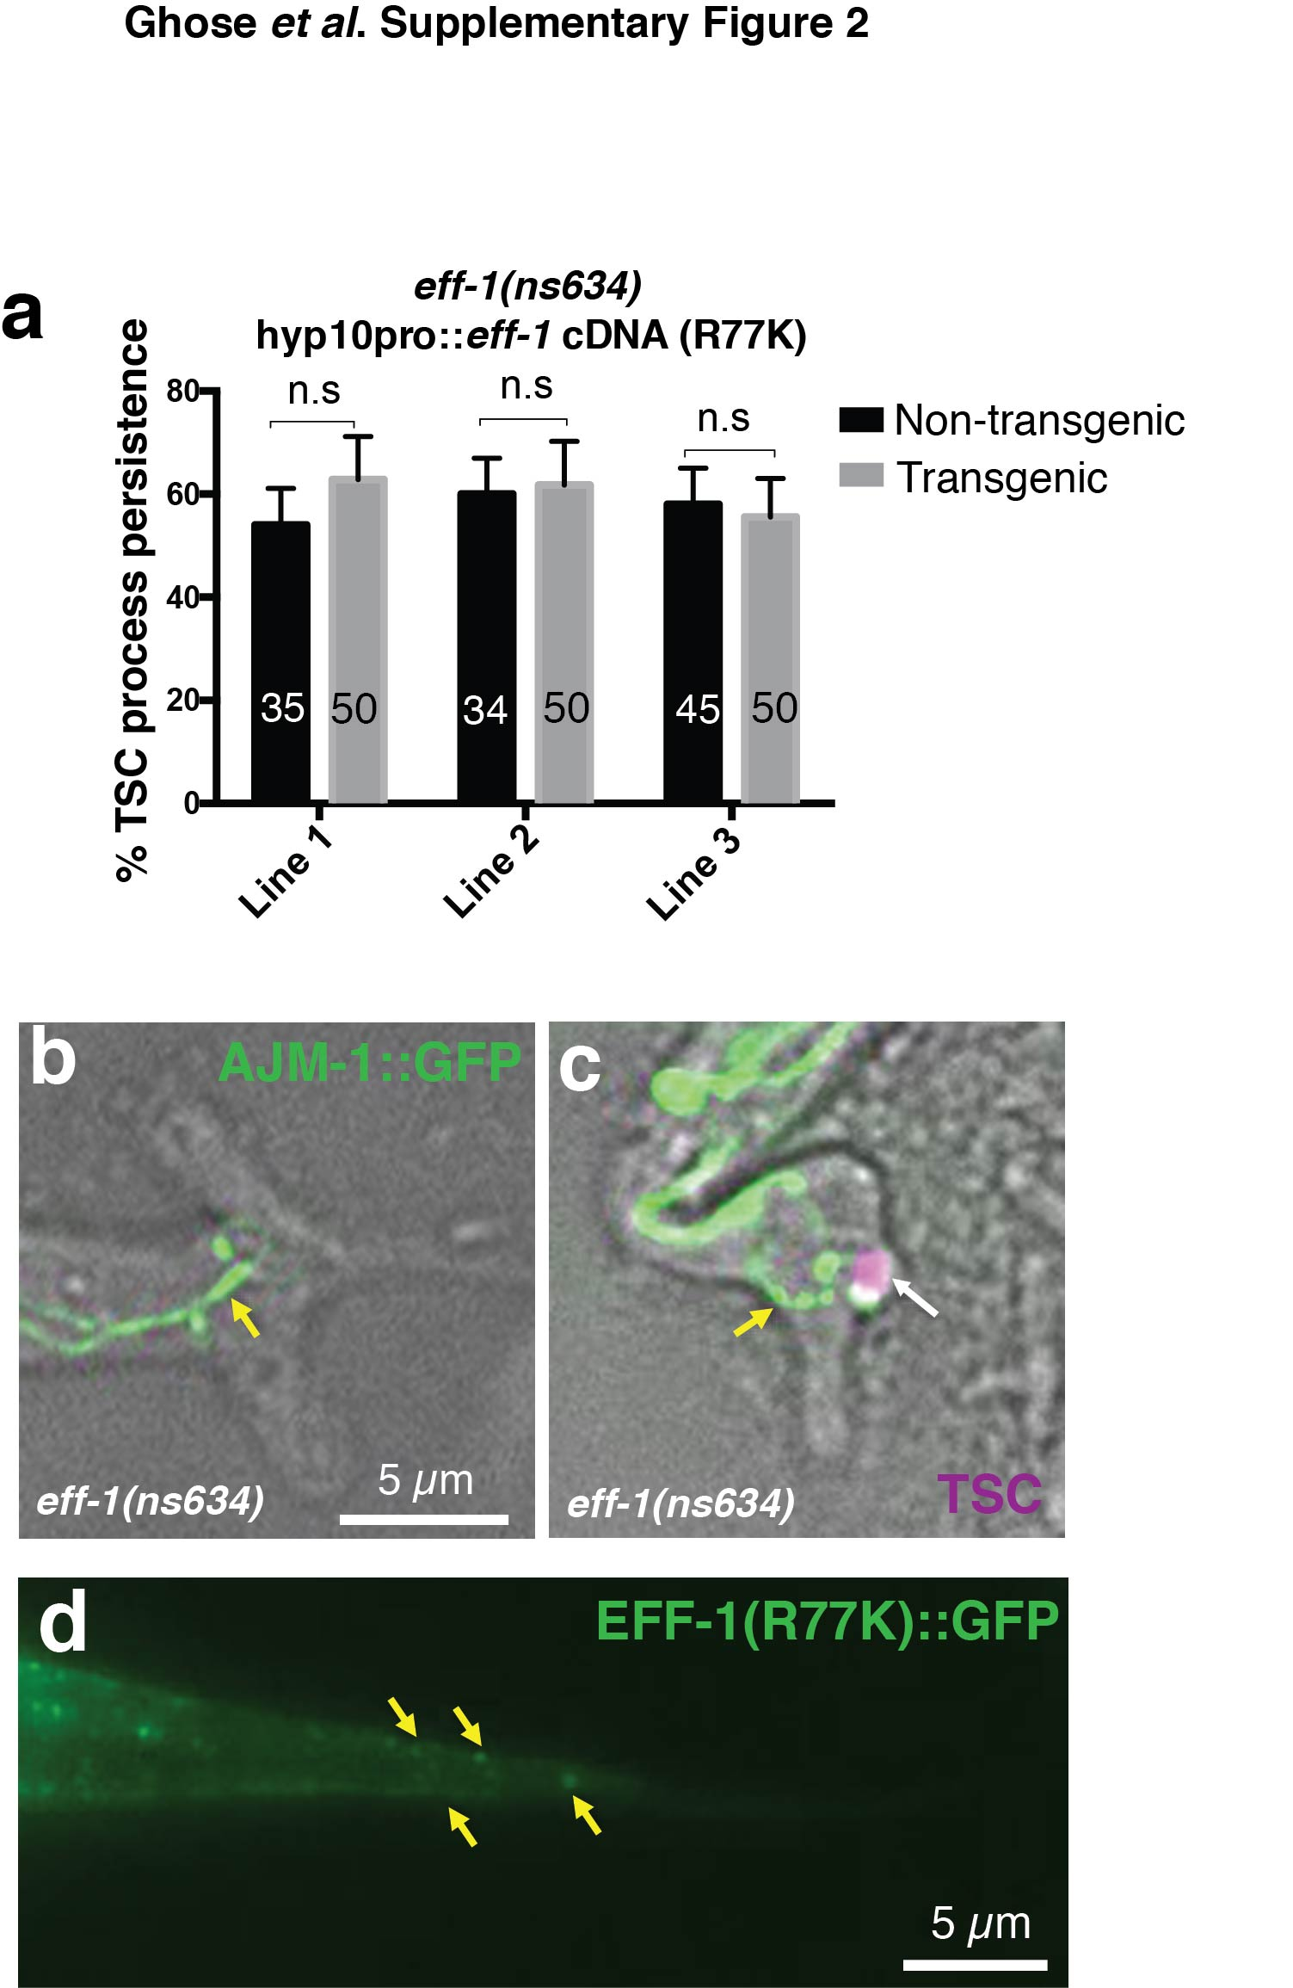
Supplementary Figure 2

R77K mutant is defective in fusion but not localization and its TSC clearance defect is independent of hyp10 cell-cell fusion defects.
(a) EFF-1(R77K) fails to rescue TSC process clearance in eff-1(ns634). n=sample sizes for statistics are as follows, Line 1: 35 (non-transgenic), 50 (transgenic); Line 2: 34 (non-transgenic), 50 (transgenic); Line 3: 45 (non-transgenic), 50 (transgenic). Data are mean +/- s.e.m. Statistics: two-tailed unpaired t-test. Individual p values: see Supplementary Table 2. Numbers inside bars, total animals scored per genotype. 3 independent transgenic lines were scored. (b, c) eff-1(ns634); TSCpro::mKate2PH animals expressing AJM-1::GFP to show apical junctions between unfused hyp10 cells. Yellow arrows indicate cell-cell junctions, white arrow, TSC. n= 20 biologically independent animals. In (b) TSC is absent. TSC is present as in (d). Wild-type L1 animal expressing EFF-1(R77K)::GFP showing EFF-1 localization at the cell membrane and in vesicles (yellow arrows); n=4 biologically independent animals. Scale bar: 5 μm.

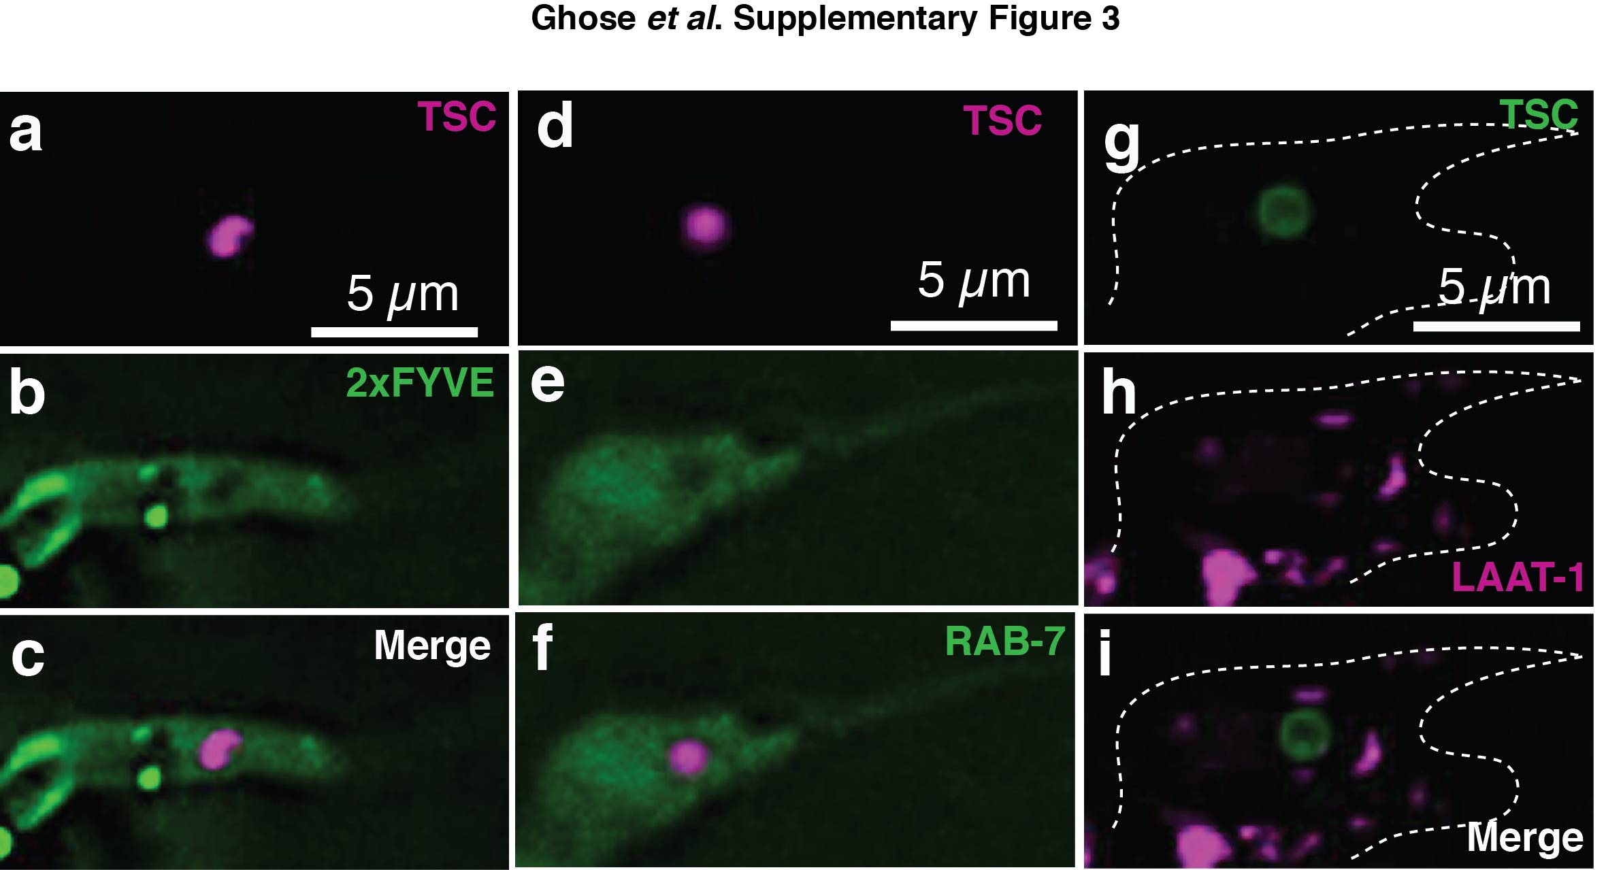
Supplementary Figure 3

Some phagosome markers do not localize around the TSC.
(a) TSCpro::mKate2PH, (b) ced-1p::GFP::2xFYVE, and (c) merge in eff-1(ns634). (d) TSCpro::mKate2PH, (e) eff-1p::GFP::RAB-7, and (f) merge in eff-1(ns634) (g) TSCpro::myrGFP, (h) ced-1p::LAAT-1::mCherry, and (i) merge in eff-1(ns634). n=10 biologically independent animals per marker. Scale bar: 5 μm.

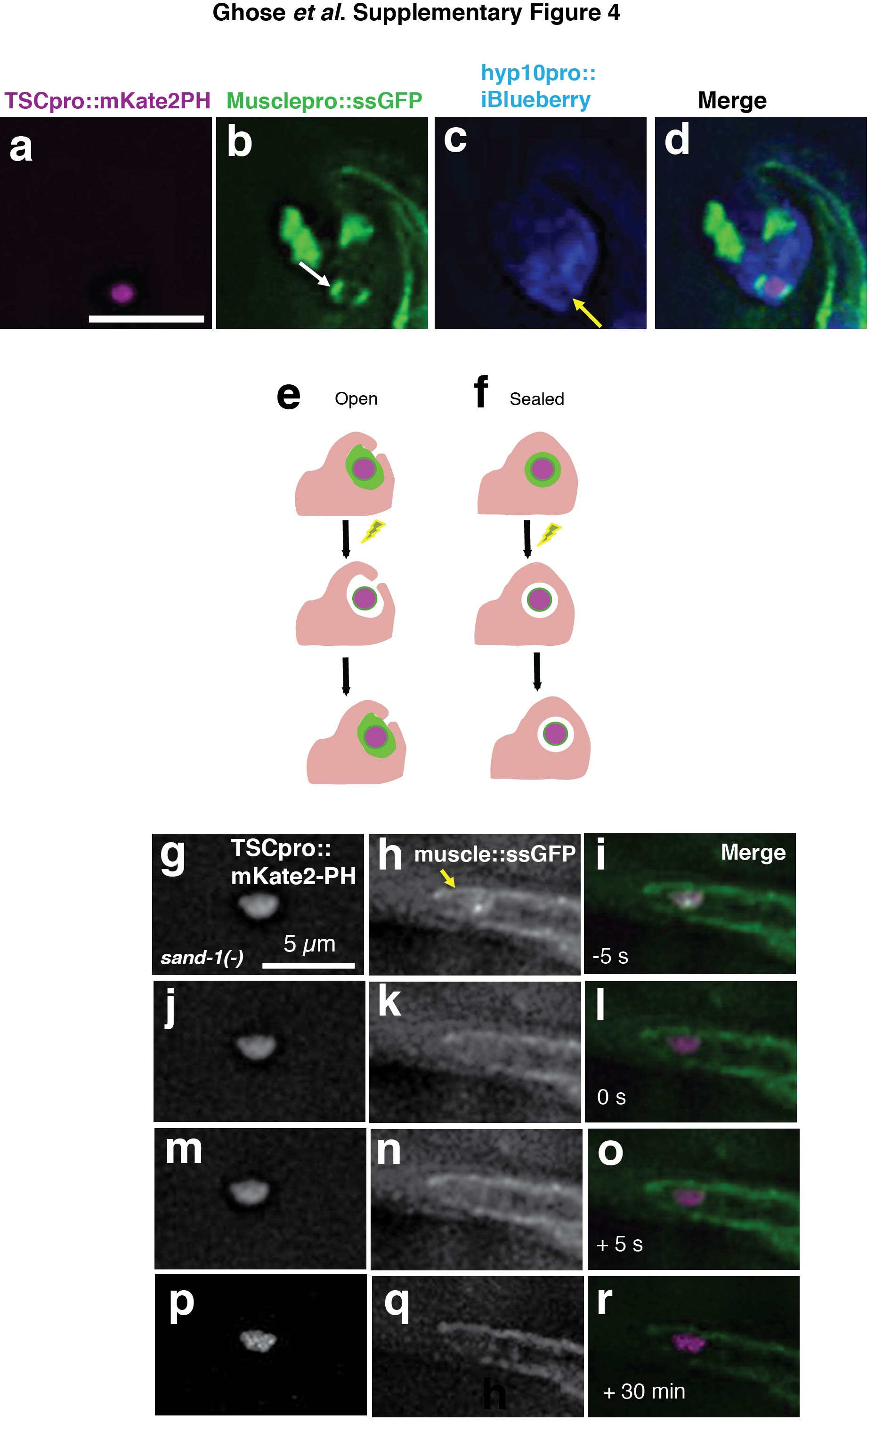
Supplementary Figure 4

Muscle-secreted ssGFP accumulates within the phagosome of eff-1(ns634);cup-2(ar506) mutants and GFP around TSC does not recover in a sand-1(or552);cup-2(ar506) FRAP experiment.
(a-d) The TSC distal process surrounded by muscle-secreted GFP (ssGFP) within an open phagosome in eff-1(ns634);cup-2(ar506) mutants. White arrow, ssGFP within phagosome; yellow arrow, phagosome opening. n=4 biologically independent animals. (e) Open phagosome model: photobleached GFP should recover by entry of extracellular GFP into the open phagosome. (f) Closed phagosome model: photobleached GFP should not recover as phagosome is sealed. (g-i) A sand-1(or552);cup-2(ar506) mutant. 5 seconds before photobleaching, (j-l) time 0 seconds, (m-o) and (p-r) 5 seconds and 30 minutes after photobleaching, respectively. Arrow, ssGFP-containing phagosome. Note GFP signal around TSC does not return. n=1. Scale bar: 5 μm.

Supplementary Movie Captions
Movie 1. iSPIM movie of TSCpro::myrGFP in a wild-type animal. Movie paused at select frames to show proximal process beading and distal process retraction from both anterior and posterior. s, soma; p, proximal process; d, distal process. Time stamps: time before hatching (0:00). Scale bar: 5 μm.
Movie 2. EM serial sections of a dying TSC cell at process beading stage. Animal is an eff-1(ns634) mutant where degeneration is comparable to WT at this stage.
Movie 3. Movie of CEM degeneration. s, soma; p, proximal process; d, distal process. Scale bar: 2.5 μm.
Movie 4. iSPIM movie of TSC of sand-1(or552). s, soma; p, proximal process; d, distal process. Time stamps: time before hatching (0:00). Scale bar: 5 μm.
Movie 5. iSPIM movie of TSC of eff-1(ns634). s, soma; p, proximal process; d, distal process. Scale bar: 5 μm.
Movie 6. Stacks of eff-1(ns634); TSCpro::myrGFP; hyp10pro::mKate2. (A) TSCpro::myrGFP, (B) hyp10pro::mKate2, (C) Merge. Scale bar: 5
Movie 7. Stacks of eff-1(ns634); TSCpro::myrGFP; hyp10pro::mKate2PH. (A) TSCpro::myrGFP, (B) hyp10pro::mKate2PH, (C) Merge. Scale bar: 5 μm.
Movie 8. Stacks of GFP::2xFYVE; TSCp::mKate2PH in eff-1(ns634). (A) TSCp::mKate2PH, (B) hyp10pro::GFP::2xFYVE, (C) Merge. Scale bar: 5 μm.
Movie 9. Stacks of GFP::RAB-7; TSCp::mKate2PH in eff-1(ns634). (A) TSCp::mKate2PH, (B) hyp10pro::GFP::RAB-7, (C) Merge. Scale bar: 5 μm.
Movie 10. Stacks of LAAT-1::mCherry; TSCp::myrGFP in eff-1(ns634). (A) TSCp::myrGFP, (B) LAAT-1::mCherry, (C) Merge. Scale bar: 5 μm.
Movie 11. Stacks of ssGFP; hyp10pro::iBlueberry in eff-1(ns634);cup-2(ar506). (A) TSCpro::mKate2, (B) Musclepro::ssGFP, (C) hyp10pro::iBlueberry, (D) Merge. Scale bar: 5 μm.
Movie 12. FRAP movie for a fast-recovering eff-1(ns634) animal. (A) TSCpro::mKate2, (B) Musclepro::ssGFP, (C) Merge. Movie shows time lapse of a single optical section at the level of the distal process remnant. First frame at -5 seconds prior to bleaching; bleaching occurs at time point 0; recovery occurs over subsequent time points. Scale bar: 5 μm.
Movie 13. FRAP movie for a fast-recovering eff-1(ns634) animal. (A) TSCpro::mKate2, (B) Musclepro::ssGFP, (C) Merge. Movie shows time lapse of a single optical section at the level of the distal process remnant. First frame at -5 seconds prior to bleaching; bleaching occurs at time point 0; recovery occurs over subsequent time points. Scale bar: 5 μm.
Movie 14. FRAP movie of sand-1(or552) animal. A) TSCpro::mKate2, (B) Musclepro::ssGFP, (C) Merge. Movie shows time lapse of a single optical section at the level of the distal process remnant. First frame at -5 seconds prior to bleaching; bleaching occurs at time point 0; no recovery observed over subsequent time points (total time 3 minutes) or 30 minutes later (not in movie). Scale bar: 5 μm.
Movie 15. Stacks of movie of EFF-1 localization with TSCpro::mKate2PH and hyp10p::iBlueberry in eff-1(ns634). (A) TSCpro::mKate2PH, (B) EFF-1*GFP, (C) hyp10p::iBlueberry. (*) refers to T173A;N529D mutation. Scale bar: 5 μm.

Supplementary Table Titles and Legends:

Supplementary Table 1.Mutants tested for tail-spike cell (TSC) persistence. +/- s.e.m. Confidence interval: 95%. Two-tailed t-test. Parentheses: P value. (*) denotes significant difference. Data are from 3 independent scoring experiments. WT, wild type. n=samples sizes for statistics are as follows, WT: 91, mtm-1(qx322): 92, piki-1(ok2346):248, lst-4(tm2423):93, ocrl-1(gk752):193, WT(25°C):100. dyn-1(ky51)(25°C): 100, tir-1(qd4): 20, btbd2(gk474291): 35.

Supplementary Table 2. P values. Statistics: two-tailed unpaired t-test. Confidence interval: 95%. Data in figure are mean +/- s.e.m. ns, not significant p>0.05. . n=samples sizes for statistics are as follows: Fig 1i: WT:70, ced-3(n717):100, ced-3(n2427): 157 (other: 42, process only: 31, soma only:47, intact: 37; Fig 2b, c: WT: 70, ced-5(n1812):86, ced-1(e1735):172, ced-1(-);ced-5(-):68, ced-2(e1752):142, ced-6(n2095):302, ced-10(n1993):198, ced-7(n1892):575, ced-8(n1981): 34; Fig 2e, f: WT:70, sand-1(or552):184), sand-1(ok1963):72 ; Fig 3b: WT: 70, ns627: 100, ns634:129, ns634+ fosmid: 51, eff-1(hy21): 108; Fig 3e: TSC Line 1: 50 (non transgenic), 50 (transgenic); TSC Line 2: 50 (non transgenic), 50 (transgenic); TSC Line 3: 49 (non transgenic), 47 (transgenic); hyp10 Lines 1-3 each: 50 (non transgenic), 50 (transgenic); Fig 3f: Line 1: Control: 61, Transgenic (not in hyp10): 33, Transgenic (in hyp10): 89; Line 2: Control: 60, Transgenic (not in hyp10): 20, Transgenic (in hyp10): 83;Fig 3g: Line 1: 60 (non-transgenic), 51 (transgenic); Line 2: 63 (non-transgenic), 51 (transgenic); Line 3: 61 (non-transgenic), 52 (transgenic); Fig 3h: Line 1: 52 (non-transgenic), 44 (transgenic); Line 2: 53 (non-transgenic), 44 (transgenic); Line 3: 45 (non-transgenic), 42 (transgenic); Fig 4h: Line 1: 32 (non-transgenic), 32 (transgenic); Line 2: 36 (non-transgenic), 47 (transgenic); Line 3: 47 (non-transgenic), 43 (transgenic); Supplementary Fig 2a: Line 1: 35 (non-transgenic), 50 (transgenic); Line 2: 34 (non-transgenic), 50 (transgenic); Line 3: 45 (non-transgenic), 50 (transgenic).

Supplementary Table 3. Primer and Plasmid Construction.

Supplementary Table 4. Transgenes

Supplementary Table 5. Mutagenesis Screen Results

